1. Kernel is an interface between hardware and software stored inside the operating system
2. Find the shell with the below commands:  
   echo $0  
   cat /etc/shells  
   cat /etc/passwd
3. Type of shells  
   Gnome  
   KDE  
   sh -> Bourne Shell  
   bash -. Bourne again shell  
   csh and tcsh  
   ksh -> compatible with csh and bash, mainly used in solaris
4. Starting a shell  
   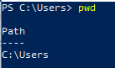
5. Run Shell scripts:  
   As absolute path: providing entire path where the shell script is located  
   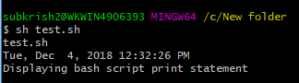

As Relative Path: ./script_name.sh  
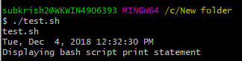

1. Script File permissions:  
   Read Write Execute  
   rwxr-xr-x
2. To change permissions  
   chmod a+x script_name
3. Rename File  
   
4. Edit a file  
   
5. Execute a shell script  
   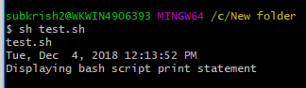
6. Sample script  
   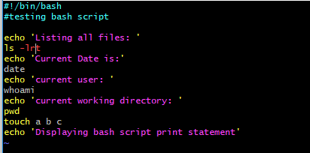  
     
   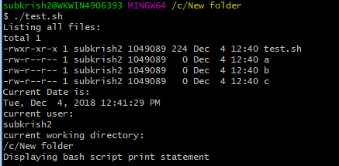
7. Troubleshooting: when we enter some incorrect command in the file and try to execute the script, shell prompts with a message that user has entered “incorrect command”
8. To check disk space  
   
9. To display all processes  
   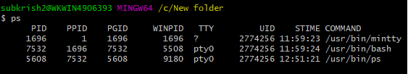
10. Free –m
11. Iostat
12. Top
13. Uptime
14. TO create directory:  
    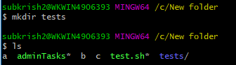
15. Defining variables:  
    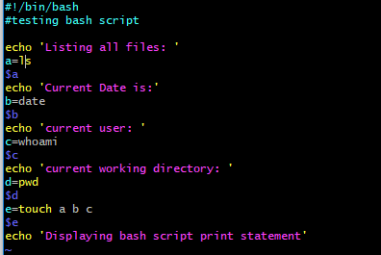
16. Input / output  
    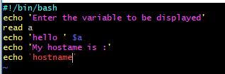  
    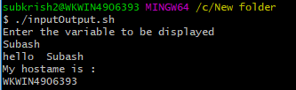
17. If then Else  
    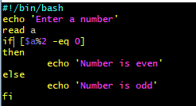
18. Switch case:

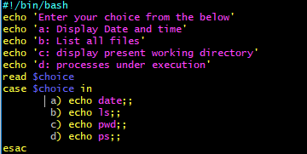

1. For Loop  
   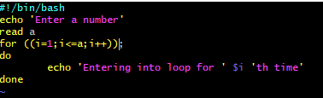  
   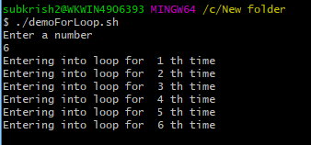
2. Do While loop  
   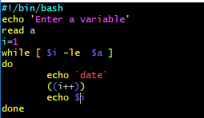  
   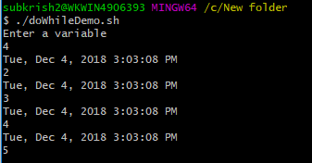
3. Exit status  
    0 -. Ok/successful  
   1 – Minor problem  
   2- serious problem  
   3-255 -. Everything else  
   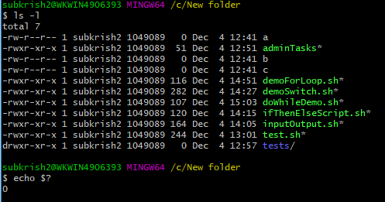  
   Since the previous command was successful, status 0 was returned  
     
   